Humberside Police Call and Crime Report Auditing System

16th October 2025
By
George Edward Langton
Student number 202216690

Word count determined by Turnitin: 2498

Contents
1. Project Overview 3
1.1. Introduction 3
1.2. Objectives 3
Primary Objectives 3
Secondary Objectives 4
1.3. Scope 5
2. Review of technical progress 6
2.1. Detailed requirements 6
2.2. Analysis of requirements 6
2.3. Options for technology and methods 6
2.4. Prototypes 6
2.5. Personas 7
2.6. What's next 7
3. Project methodology and outcomes 8
3.1. Initial project plan 8
3.1.1. Tasks and milestones 8
3.1.2. Schedule Gantt chart 10
3.2. Project control 16
3.3. Project evaluation 16
4. References 17

Project Overview

Introduction
As stated in the PDD, within Humberside Police, there is a team, Crime Data Admin, whose job is to audit call logs and crime reports to ensure that the rules for data capture are being complied with, such as assigning the necessary markers and applying data in the force management system, Niche. (Niche Technology, 2025). When errors are identified, the team submits a report, which the officer then acts upon to correct and ensure that the data is kept to the highest standard, both for court proceedings and to follow best data management practices. If an officer accumulates several errors across similar logs and routinely causes data-quality issues, the issue is escalated to their supervisor for discussion.
The team seeks improved data tracking to identify the recurring problems and enable targeted training to prevent repeated mistakes. Currently, this process is manual, involving forms and follow-up emails, which creates inefficiencies and contributes to a growing backlog.
The project aims to automate and streamline these tasks by developing an interactive user interface and database, which will allow them to conduct their audits and generate feedback automatically, saving the team time.

Objectives
Both the primary and secondary objectives remain unchanged.

Scope
The scope of this project currently remains unchanged. However, current progress suggests there may be scope to broaden the project once development is complete, assuming time allows. Currently, development is running a week ahead of plan. Assuming pace is maintained, a review of the scope will be conducted and may be broadened to include sentiment tracking/sentiment extraction from forms completed within the application to improve data on the stats screen. This may be done via an API or through the application's code; however, this is not yet in scope for the project, as this stage has not yet been fully agreed upon by Humberside Police and is time-dependent.

Review of technical progress

Detailed requirements
During the PDD stage, the requirements were reviewed, and they remain the same. The project needs to run effectively and meet all the objectives laid out in the PDD.
That being to develop:
- A user interface which has a section for a form to be filled out, which will give feedback for the member of the Crime Data admin Team to send along as a Dashboard which can be used to see the most consistent errors and other statistics regarding the audits.
- A database with tables that will go with the interface that will allow for the relevant data to be stored, with security considerations and data validation.
- A Comprehensive read me letting the IT team or any other users know how to set this system up.

Analysis of requirements
This project will be developed using the Waterfall methodology. It is a well-structured approach that tackles each section one part at a time, with clearly defined steps. The definition has already been applied to some user goals. Microsoft Planner will be used to monitor tasks and progress and stay on the Timeline. The success of this project will be measured by its ability to meet the project brief and the satisfaction of the stakeholders.

Options for technology and methods
Tools available for the Project
- Database: SQL Server (the only available option)
- Interface development: HTML, CSS and JavaScript or React
- Dashboard/Visualisation: Tableau (Salesforce, 2025) or Python
- Automation & Emails, API, Python or Button On interface.
- Project Management: Microsoft Planner (Microsoft, 2025) or Trello
Evaluation for Selection:
- Compare tools' cost, compatibility and time consumption and then choose the tools that best fit with the project and the force to enable this project to be fully completed

Personas

Prototype

What's next

Project methodology and outcomes

Initial project plan

Tasks and milestones
This project will be broken down into tasks and sprints in accordance with the Waterfall Methodology. In each step, however, there will be at least one milestone, if not more, through the stages as defined below. At each Milestone, A meeting will take place with the stakeholder to ensure their happiness.
Milestone | Milestone details | Complete?(%)
Pre-Design | - Project Definition Document  - Literature Review  - Technology Survey/ Analysis  - Choose the Technology that will be used for development | 75%
Early Prototyping | - Sketching out the user interface design  - Creating wireframes based on the sketches  - Design/Draw the databases required and the table relationships.  - Show stakeholders the Design and ensure they are happy.  - Create personas based on Data Admin Team Experiences.
Prototyping | - Establish Questions for the Forms  - Design Prototype In a prototyping tool such as Figma  - Sample Data and create Mock data for the application  - Demonstrate the interactive prototypes and ensure that the Data admin team is happy
Forms section Complete | - Build the database/database schema and populate with mock data  - Build the User interface for the Header of the page and the forms section, leaving a placeholder for the dashboard for now  - Fill the Table in the database with form questions  - Hook the Database table up to the forms interface  - Check form displays correctly  - Build Edit form functionality  - Build the Feedback functionality
Admin Profiles Complete | - Build the Admin Login System into the Interface  - Lock edit questions functionality to admin
Dashboard | - Build the dashboards Page  - Build the data charts/Display  - Build a system to highlight recurring issues to the Staff

Schedule Gantt chart

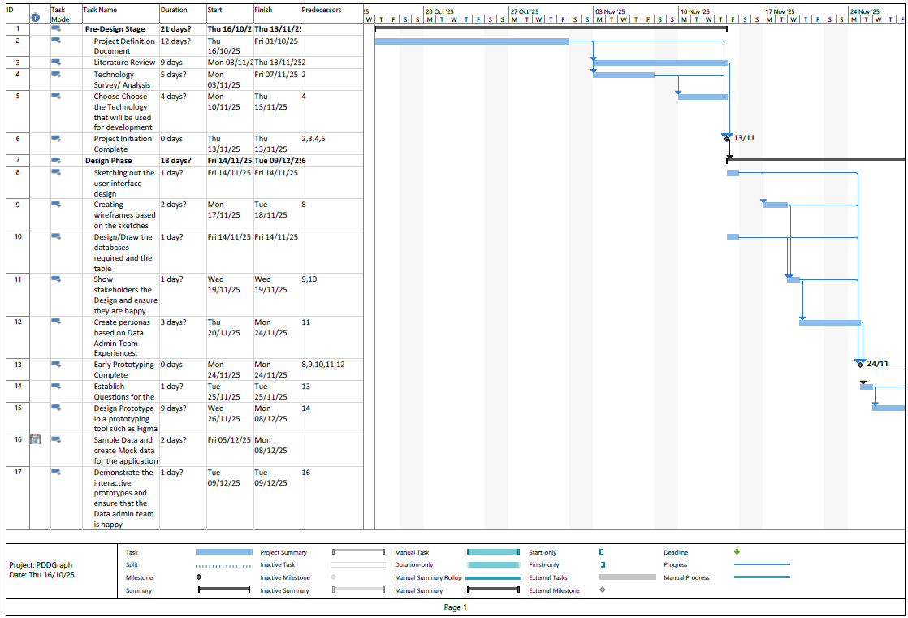
Figure 3: Gantt Chart Top Section
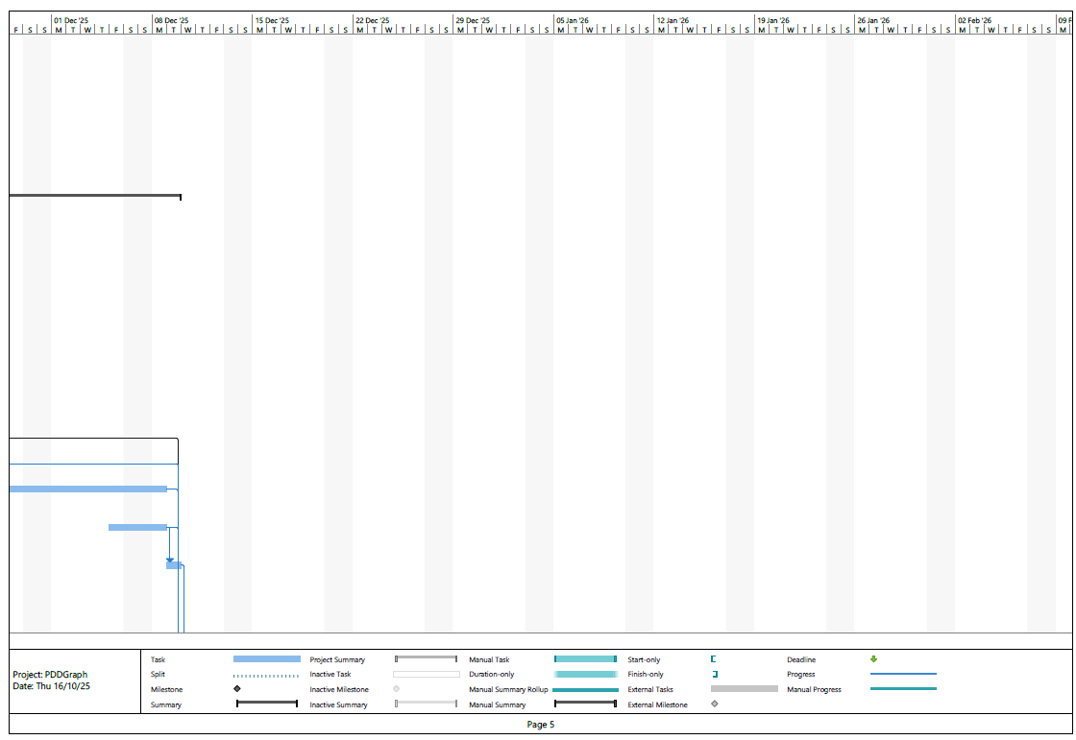
Figure 4 Gantt Chart Top Section Second Part
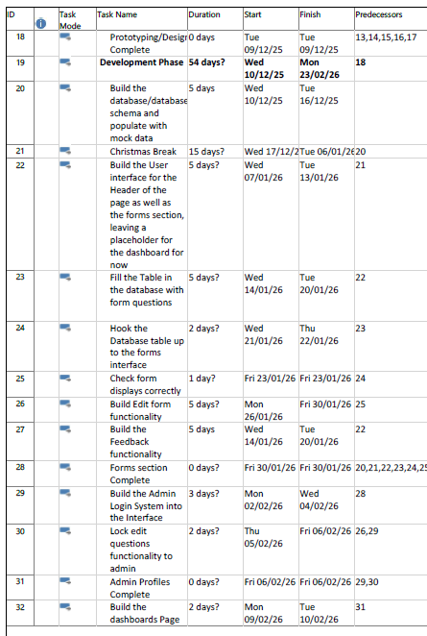
Figure 5 Mid Section Tasks

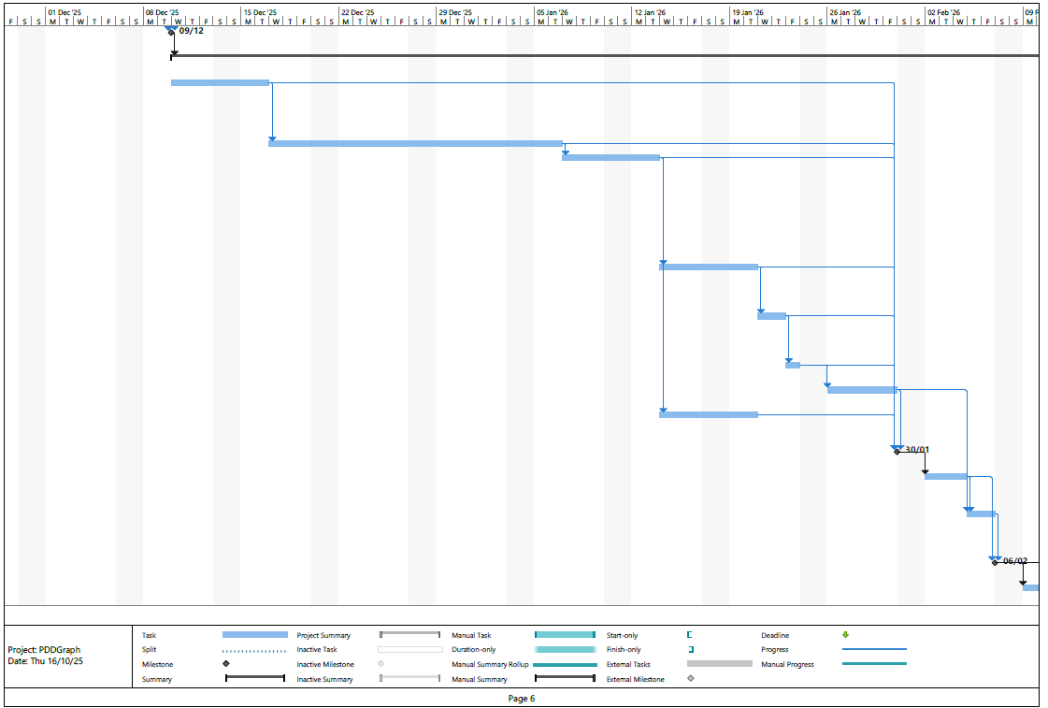
Figure 6: Mid section Gantt Chart
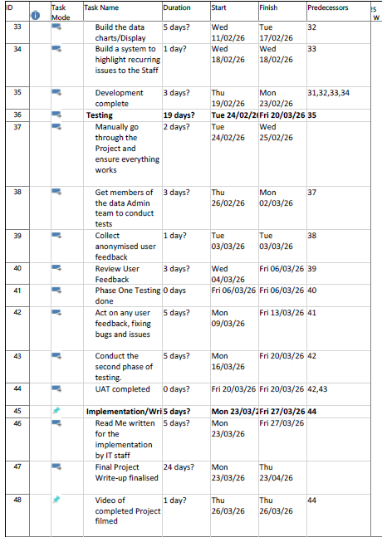
Figure 7: Bottom of Gantt Chart

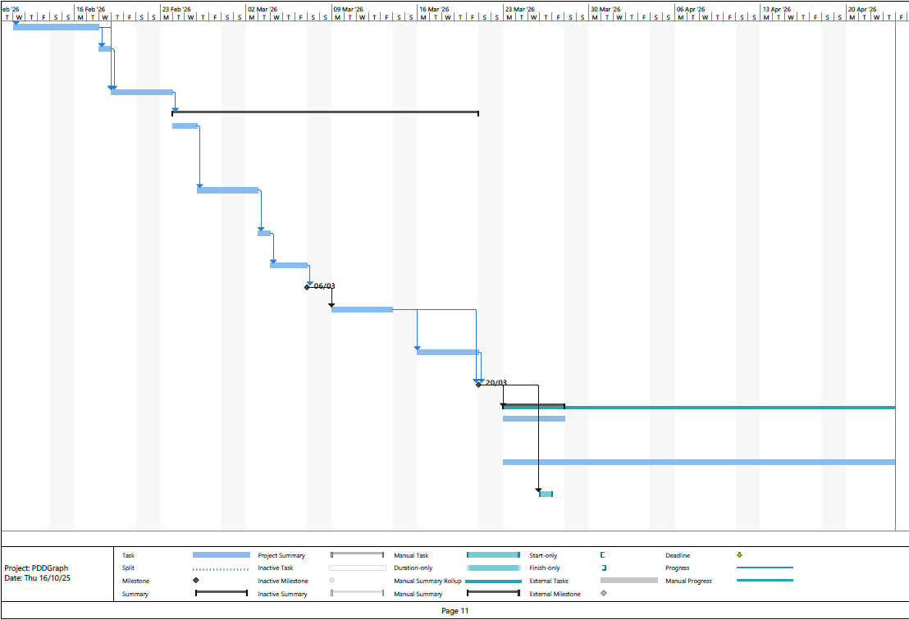
Figure 8 Gantt chart Bottom

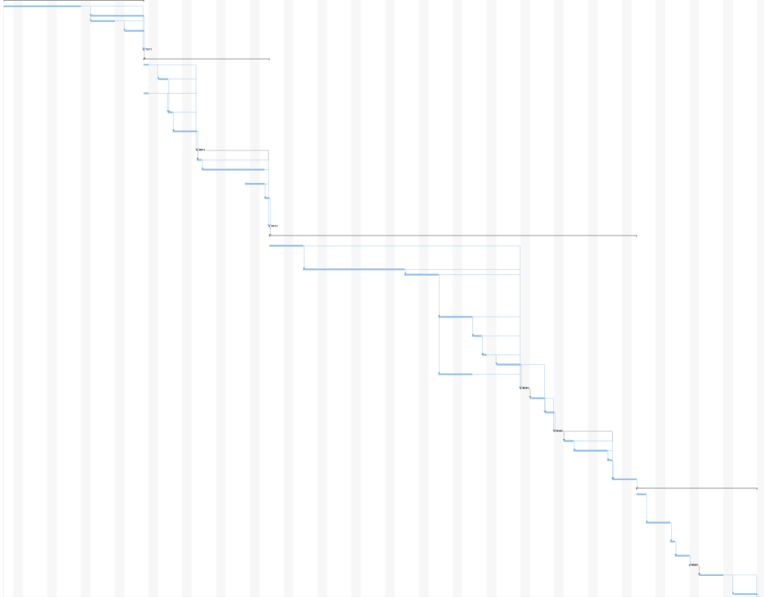
Figure 9: Gantt Chart in full (low visibility)

Project control
Microsoft Planner will be used to monitor progress by creating sections for each task, setting relevant deadlines, and checking them off as the project progresses. This will be assessed against the Gantt chart to ensure that the timeline is met. The intention is to have 8 hours a week set aside for this project.

Project evaluation
The project will be tested on live participants and has been included in the ethics review. Evaluation will be conducted through user feedback gathered via anonymised forms. It will be tested on multiple staff members of different levels, including both staff and management, to ensure everyone is happy with the system. There will be two rounds of testing, with feedback acted on at both occasions. This project will then be evaluated through its ability to meet all objectives and deliver all deliverables.

References
Microsoft. (2025, 10 8). Microsoft Planner. Retrieved from Microsoft: https://www.microsoft.com/en-us/microsoft-365/planner/planner-and-project-support
Niche Technology. (2025, 10 12). nicherms. Retrieved from nicherms: https://nicherms.com/
Salesforce. (2025, 10 15). tableau. Retrieved from tableau: https://www.tableau.com/en-gb

